Overview:
BC’s Opioid Emergency Response Updated Provincial Structure

An updated provincial structure to respond to the opioid crisis was announced December 2017 by the Minister of Mental Health and Addictions. The structure builds on work to date and aims to create a revitalized, streamlined, scaled up response involving multi-sector collaboration with public and community agencies as well as people with lived experience.
The new structure creates a BC-wide Overdose Emergency Response Centre (OERC) Chaired by Dr. Patricia Daily. It is headquartered at Vancouver Coastal Health’s Emergency Response Centre in Vancouver. It is led by the Ministry of Mental Health and Addictions in partnership with Health, Public Safety and the Social ministries.
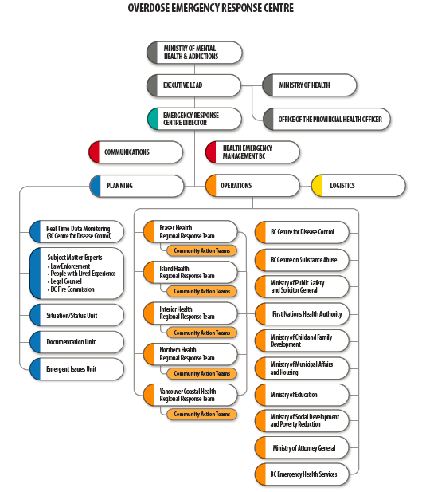

Regional Response Team:
Health authority-area based team mandated to develop and lead regional (health authority-wide) implementation plans to ensure a comprehensive response. The Regional Response Team actively monitors community overdose indicators and supports community actions. Membership includes Health Authorities, Medical Health Officers, First Nations Health Authority, First Responders and representatives from persons with lived experience (users and/or family).
The Regional Response Team supports the development of Community Action Teams in priority communities. Campbell River, Nanaimo, Port Alberni, Duncan and Victoria have been identified as initial priority communities on Vancouver Island.
Community Action Teams:
Community Action Teams are established in communities identified via data as having most urgent need and are led by the Regional Response Team. The Community Action Teams are ideally based on community tables already in place with membership adjusted as required. The Community Action Teams ensure a high level of local coordination and on-going communication among community stakeholders and escalates priority issues to the provincial and regional levels.
Team membership includes representation from: Municipality, First responders, Front-line Community Agencies, Divisions of Family Practice, User Groups, Local Government Agencies and the Health Authority.
Comprehensive Package of Interventions:
The Overdose Emergency Response Centre structure is taking a World Health Organization/Global Fund approach to program implementation, capitalizing on evidence-based interventions with proven efficiency across Comprehensive Package of Interventions:
